Physical Fitness

In addition to regular exercise, this area includes proper nutrition, injury prevention, and recovery to maximize performance.

Internal Resources

Warrior Yoga (Join GroupMe for class updates)
Wednesday at 1500 hours
Tulsa Police Academy
Tuesday and Thursday 1200 hours
Comstat

Sheepdog Combatives (Join GroupMe for class updates)
Mondays and Thursdays at 1100 hours
Tulsa Police Academy

Ground Zero Fitness
Monday-Friday at 0700 hours
Tulsa Police Academy

Cooper Fitness Norms

Heroes Workouts

Nutrition Basics for a Healthy Lifestyle
CLEET 16-1489

Nutrition Tips and Guidelines

External Resources


Akins Natural Food
https://www.atkins.com/
All Tulsa locations and online
15% off for first responders

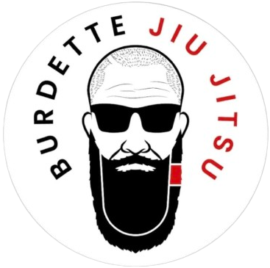
Burdette Jiu Jitsu
https://burdettejiujitsu.com/
First Responders – Free training until Blue Belt


Carson Fight & Fitness
https://carsonfightfitness.com/
$99/month for First Responders & Veterans- all programs


Connect DME
(Home Sleep studies, CPAP, supplies, etc.)
https://connectdme.com/


Eastern Oklahoma Wellness and Chiropractic Clinic
(Chiropractic care, Physical Therapy, Hormone Management)
https://www.eowc.net/


Fenix Strength and Conditioning
www.Fenixstrong.com
20% off any membership

Tactical Performance – Performance Training for First Responders & Combat Athletes
https://fenix.pushpress.com/landing/plans/plan_e6a3e395916178/login
$50/month

Gold BJJ
https://goldbjj.com/pages/military-and-first-responder-discount?srsltid=AfmBOoq49CLDHM1390oz6mCVjmUg2Cdz5hgZ1b_ReMWNlgc_GSWeRzi8
35% off on all gear for military and first responders

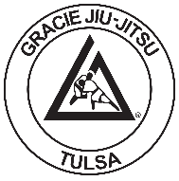
Gracie Jiu-Jitsu Tulsa
www.gracietulsa.com
25% off for police, fire, and veterans


Omar French BJJ
www.omarfrench.com
10% off for police, fire, and veterans


Relentless Martial Arts
http://www.relentlessmartialarts.com/


Triton Fight Center
www.tritonfightcenter.org
Police Officers – free training until Blue Belt
Veterans – free training with proof of combat engagement or 80%-100% disability rating


TTown Fitness
10% off for military, fire and police


Wellbeing Solutions
(Health Coaching, Nutrition and Exercise Coaching, etc.)
https://wbs.health/services/

** If you know of any resources not currently listed, please provide that information to Sgt. Mike Griffin at mgriffin@cityoftulsa.org or Officer Erin Bitting at ebitting@cityoftulsa.org

